**JQuery Assignment**

Question answer:-

1 what is Jquery? Jquery is a lightweight “write less and do more” java script library. Jquery is to make it much easier to use java script on your website. Jquery takes lot of common task that line of java script code and wrap them method that you can with a single line code.

2 How to Apply CSS Using JQuery, How to Add Class and Remove Class in Jquery, JQuery Animation?

jQuery has several methods for CSS manipulation. We will look at the following methods:

add Class() - Adds one or more classes to the selected elements

remove Class() - Removes one or more classes from the selected elements

toggle Class() - Toggles between adding/removing classes from the selected elements

css() - Sets or returns the style attribute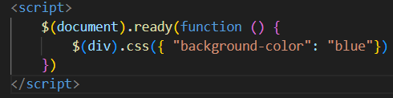

3 How to create slider with animation?

1 To create the basic layout of the image slider using html code. 2 add previous and next button. 3 select effect option or text you want to animate. 4 select animation and choose an animation. 5

